|  |  |
| --- | --- |
| **­** | **MINISTRY OF EDUCATION AND TRAINING** |

**FPT UNIVERSITY**

|  |  |
| --- | --- |
| **Report 2** | |
| **Parking Guidance System Solution** | |
| **Group 1** | |
| **Group members** | Trần Nguyễn Minh Trung – Team Leader – SE61496  Bùi Phú Hiệp – Team Member – SE61438  Nguyễn Đỗ Phương Huy – Team Member – SE61358 |
| **Supervisor** | Nguyễn Đức Lợi |
| **Ext. Supervisor** | N/A |
| **Capstone Project Code** | PGSS |

- Ho Chi Minh City, Jan, 2017

*This page is intentionally left blank*

# Table of Contents

Table of Contents 1

List of Tables 2

List of Figures 2

Definitions, Acronyms and Abbreviations 2

B. Software-Hardware Project Management Plan 3

1. Problem Definition 3

1.1. Name of this Capstone Project 3

1.2. Problem Abstract 3

1.3. Project Overview 3

1.3.1. Current Situation 3

1.3.2. The Proposed System 3

1.3.3. Boundaries of the System 3

1.3.4. Futures Plans 3

1.3.5. Development Environment 3

1.3.5.1. Hardware requirements 3

1.3.5.2. Software requirements 3

2. Project organization 3

2.1. Software Process Model 3

2.2. Roles and responsibilities 3

2.3. Tools and Techniques 3

3. Project Management Plan 3

3.1. Software development life cycle 3

3.2. Phase Detail 3

3.3. All Meeting Minutes 3

4. Coding Convention 3

# List of Tables

Table 1: Definitions, Acronyms and Abbreviations 2

# List of Figures

Figure 1: Indoor parking area 4

Figure 4: Outdoor parking area 5

Figure 2: Parking area with PGS 6

Figure 3: Zone Control Unit 7

# Definitions, Acronyms and Abbreviations

|  |  |
| --- | --- |
| **Name** | **Definition** |
| PGS | Parking Guidance System |
| Parking area | An area set aside for parking vehicles, aircraft, etc. |
| Parking lot | A place inside parking area that provide space for one vehicle |
| IoT | Internet of Things |

Table 1: Definitions, Acronyms and Abbreviations

# B. Software-Hardware Project Management Plan

## Problem Definition

### Name of this Capstone Project

* Official name: Parking Guidance System Solution
* Vietnamese name: Giải pháp hệ thống chỉ dẫn đỗ xe
* Abbreviation: PGSS

### Problem Abstract

As the economy of Vietnam growth, the number of personal cars also increasing, and that create a high proportion of traffic generated by drivers seeking vacant sparking lots. The current common Parking Guidance Systems in Vietnam are only suitable for a small number of indoor parking areas, and can’t be implemented for outdoor parking areas, because of the need of complicated planning and wiring. Moreover, all of the current PGS parking areas are working separately in their own local area network so there is no way for drivers to know the current available parking lots except by coming to the entrance.

We provide a system which ease the complicated in set up a PGS for parking areas. Furthermore, we make the system in a way that each PGS parking area can connect to each other so we can provide more information to drivers to help them find a suitable parking areas more quickly and easily.

### Project Overview

#### Current Situation

Below are the problems encountered in this project:

* **Parking Operate Knowledge:** We are not experts in parking operating. All functions and features are developed in order to serve the needs which we had identified during 4 months of research.
* **Hardware Knowledge:** We are inexperienced with hardware. All the hardware components chosen to be used in this project is based on our familiar with them, or based on the shortest time we need to learn how to use them. So they are only the most appropriate, not the best choice for the project.
* **Single point of failure:** The communication of the PGS system and server is highly depended on the Central Control Unit in each parking area. So if the Central Control Unit crash, the PGS can no longer commute with server.
* **Server crash:** All the needed data for the app is stored in the server. So if server crash, all the devices cannot get parking area information.
* **Security:** Currently, there is few possible problems encountered with RF, as RF is vulnerable to replay attack.

#### The Proposed System

#### Boundaries of the System

#### Futures Plans

#### Development Environment

##### Hardware requirements

##### Software requirements

## Project organization

### Software Process Model

This project is developed under Iterative and incremental development model. We apply customized Iterative and incremental development model to capable with current situation in our team. We choose this model because of the following reasons:

* We are still inexperienced and by develop the system through iterations (repeated cycles) and incrementally (in small portions of time), we can learn from our mistakes and apply that knowledge on the next iteration.
* We are researching and developing the system at the same time, so using this model allow us more flexibility to adapt to changes.
* Working with embedded system hides a lot of problems that are unknown in the planning phase until it is too late. With Iterative and incremental development model, we test the system in small portion at a time, therefore reduce risk and build a feature rich and robust system.

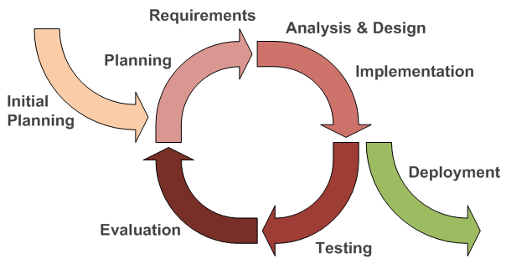

Figure : Iterative and Incremental development

### Roles and responsibilities

|  |  |  |  |
| --- | --- | --- | --- |
| **No** | **Full name** | **Team Role** | **Responsibilities** |
| 1 | Nguyễn Đức Lợi | Supervisor, Project Manager | * Specify user requirement * Advisor for ideas and solutions * Control the development process * Give out techniques and business analysis support |
| 2 | Trần Nguyễn Minh Trung | Team Leader, BA, Developer, Tester | * Managing process * Managing budget * Dividing tasks for team member * Create test plan * Clarifying requirements * Prepare document * Coding * Testing |
| 3 | Bùi Phú Hiệp | Team Member, Developer, Tester | * Create test plan * Clarifying requirements * Prepare document * Coding * Testing |
| 4 | Nguyễn Đỗ Phương Huy | Team Member, Developer, Tester | * Create test plan * Clarifying requirements * Prepare document * Coding * Testing |

Table : Roles and Responsibilities Details

### Tools and Techniques

## Project Management Plan

### Software development life cycle

### Phase Detail

### All Meeting Minutes

## Coding Convention